ASR Score Calculation:
The Points System
© 2010, W. Wesley Johnston
As the war approached an end in Europe, the Army devised a system of points to provide for the equitable disposition of the soldiers in Europe. High point men would come home and receive their discharge before low point men. Low point men would train for the invasion of Japan.
The Adjusted Service Rating (ASR) card is shown below (an example published in either Yank or Stars and Stripes).
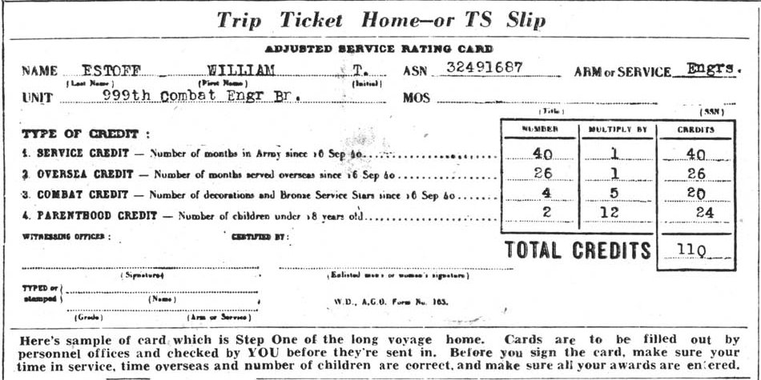
The system provided a weighted ASR score, based on four criteria:
- Months in service (multiplied by 1)
- Months overseas (multiplied by 1)
- Number of decorations and Bronze Service Stars (multiplied by 5)
- Number of children under 18 (multiplied by 12)
Ideally, the system provided for the transfer of high point men out of their units and into units that were scheduled for shipment home sooner than their original unit. In practice, the system sometimes resulted in a soldier returning home after his original unit instead of before. (SNAFU)
The low point men often arrived in the States before the high point men. They received a 30-day leave before having to report to their new unit for training for the invasion of Japan. However the war in Japan ended before their leave did. But they still had to wait their turn for discharge. So they reported back for duty and did little but while away time until the high point men had returned home and received their discharges. Thus the low point men often received their discharges in early 1946.
In the months after V-E Day, the Army several times reduced the threshold of points needed for shipment home. Units also looked after their men who had seen dedicated service for the duration. The number of Bronze Star Medals issued in the weeks after V-E Day greatly increased, since such an award also added 5 points to a soldier’s ASR score. Unit commanders also went back through the records to issue overlooked Purple Hearts, also adding 5 points to a soldier’s ASR score.

